World Fairy Tale Comparison/Contrast Chart 

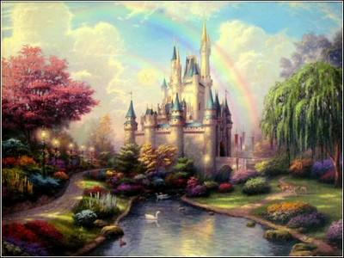

Title of Story | Country of Origin | Author | Main Character’s Name and Description
“Evil” Character (s)  and Description | Elements of Magic | A Description of the character representing the “Prince” | Animals as Characters
“Cinderella” Character’s Conflict | How does the “Cinderella” character triumph? | What is the story’s resolution? | List Specific Cultural References

