Russia’s Golden Slipper


There was once upon a time an old man and an old woman, and the old man had a daughter, and the old woman had a daughter. And the old woman said to the old man, “Go and buy a heifer, that thy daughter may have something to look after!” So the old man went to the fair and bought a heifer.
Now the old woman spoiled her own daughter, but was always snapping at the old man’s daughter. Yet the old man’s daughter was a good, hard-working girl, while as for the old woman’s daughter, she was but an idle slut. She did nothing but sit down all day with her hands in her lap. One day the old woman said to the old man’s daughter, “Look now, thou daughter of a dog, go and drive out the heifer to graze! Here thou hast two bundles of flax. See that thou unravel it, and reel it, and bleach it, and bring it home all ready in the evening!” Then the girl took the flax and drove the heifer out to graze.
So the heifer began to graze, but the girl sat down and began to weep. And the heifer said to her, “Tell me, dear little maiden, wherefore dost thou weep?”––“Alas! why should I not weep? My stepmother has given me this flax and bidden me unravel it, and reel it, and bleach it, and bring it back as cloth in the evening.”––“Grieve not, maiden!” said the heifer, “it will all turn out well. Lie down to sleep!”––So she lay down to sleep, and when she awoke the flax was all unraveled and reeled and spun into fine cloth, and bleached. Then she drove the heifer home and gave the cloth to her stepmother. The old woman took it and hid it away, so that nobody might know that the old man’s daughter had brought it to her.
The next day she said to her own daughter, “Dear little daughter, drive the heifer out to graze, and here is a little piece of flax for thee, unravel it and reel it, or unravel it not and reel it not as thou likest best, but bring it home with thee.” Then she drove the heifer out to graze, and threw herself down in the grass, and slept the whole day, and did not even take the trouble to go and moisten the flax in the cooling stream. And in the evening she drove the heifer back from the field and gave her mother the flax. “Oh, mammy!” she said, “my head ached so the whole day, and the sun scorched so, that I couldn’t go down to the stream to moisten the flax.”––“Never mind,” said her mother, “lie down and sleep; it will do for another day.”
And the next day she called the old man’s daughter again, “Get up, thou daughter of a dog, and take the heifer out to graze. And here thou hast a bundle of raw flax; unravel it, heckle it, wind it on to thy spindles, bleach it, weave with it, and make it into fine cloth for me by the evening!”––Then the girl drove out the heifer to graze. The heifer began grazing, but she sat down beneath a willow-tree, and threw her flax down beside her, and began weeping with all her might. But the heifer came up to her and said, “Tell me, little maiden, wherefore dost thou weep?”––“Why should I not weep?” said she, and she told the heifer all about it.––“Grieve not!” said the heifer, “it will all come right, but lie down to sleep.”––So she lay down and immediately fell asleep. And by evening the bundle of raw flax was heckled and spun and reeled, and the cloth was woven and bleached, so that one could have made shirts of it straight off. Then she drove the heifer home, and gave the cloth to her stepmother.
Then the old woman said to herself, “How come it that this daughter of the son of a dog has done all her tasks so easily? The heifer must have got it done for her, I know. But I’ll put a stop to all this, though daughter of the son of a dog,” said she. Then she went to the old man and said, “Father, kill and cut to pieces this heifer of thine, for because of it thy daughter does not have a stroke of work. She drives the heifer out to graze, and goes to sleep the whole day and does nothing.”––“Then I’ll kill it!” said he.––But the old man’s daughter heard what he said, and went into the garden and began to weep bitterly. The heifer came to her and said, “Tell me, dear little maiden, wherefore dost thou weep?”––“Why should I not weep,” she said, “when they want to kill thee?”––“Don’t grieve,” said the heifer, “it will all come right. When they have killed me, ask thy stepmother to give thee my entrails to wash, and in them thou wilt find a grain of corn. Plant this grain of corn, and out of it will grow up a willow-tree, and whatever thou dost want, go to this willow-tree and ask, and thou shalt have thy heart’s desire.”
Then her father slew the heifer, and she went to her stepmother and said, “Prythee, let me have the entrails of the heifer to wash!”––And her stepmother answered, “As if I would let anybody else do such work but thee!”––Then she went and washed them, and sure enough she found the grain of corn, planted it by the porch, trod down the earth, and watered it a little. And the next morning, when she awoke, she saw that a willow-tree had sprung out of this grain of corn, and beneath the willow-tree was a spring of water, and no better water was to be found anywhere in the whole village. It was as cold and as clear as ice.
When Sunday came round, the old woman tricked her pet daughter out finely, and took her to church, but to the old man’s daughter she said, “Look to the fire, thou slut! Keep a good fire burning and get ready the dinner, and make everything in the house neat and tidy, and have thy best frock on, and all the shirts washed against I come back from church. And if thou hast not all these things done, thou shalt say good-bye to dear life.”
So the old woman and her daughter went to church, and the smart little stepdaughter made the fire burn up, and got the dinner ready, and then went to the willow-tree and said, “Willow-tree, willow-tree, come out of thy bark! Lady Anna, come when I call thee!” Then the willow-tree did its duty, and shook all its leaves, and a noble lady came forth from it. “Dear little lady, sweet little lady, what are thy commands?” said she.––“Give me,” said she, “a grand dress and let me have a carriage and horses, for I would go to God’s House!”––And immediately she was dressed in silk and satin, with golden slippers on her feet, and the carriage came up and she went to church.
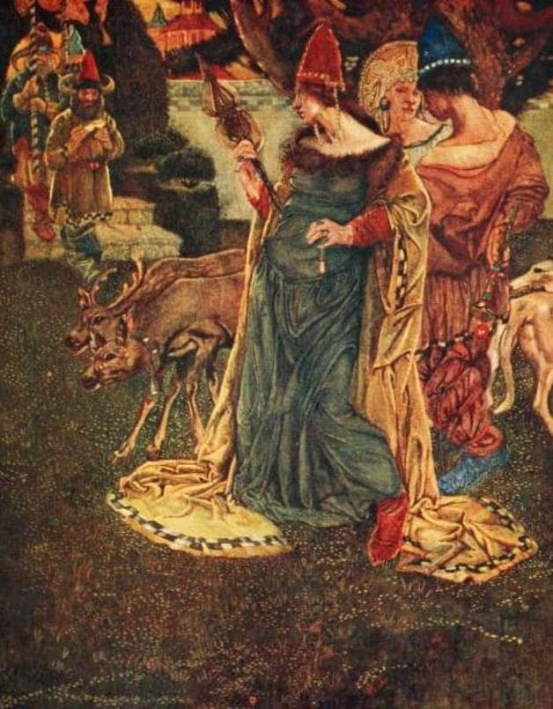
When she entered the church there was a great to-do, and everyone said, “Oh! oh! oh! Who is it? Is it perhaps some princess or some queen? For the likes of it we have never seen before.” Now the young Tsarevich chanced to be in church at that time. When he saw her, his heart began to beat. He stood there, and could not take his eyes off her. And all the great captains and courtiers marvelled at her and fell in love with her straightway. But who she was, they knew not. When service was over, she got up and drove away. When she got home, she took off all her fine things, and put on all her rags again, and sat in the window-corner and watched the folk coming from church.
Then her stepmother came back too. “Is the dinner ready?” said she.––“Yes, it is ready.”––“Hast thou sewn the shirts?”––“Yes, the shirts are sewn too.”––Then they sat down to meat, and began to relate how they had seen such a beautiful young lady at church.––“The Tsarevich,” said the old woman, “instead of saying his prayers, was looking at her all the while, so goodly was she.” Then she said to the old man’s daughter, “As for thee, thou slut! though thou hast sewn the shirts and bleached them, thou art but a dirty under-wench!”
On the following Sunday the stepmother again dressed up her daughter, and took her to church. But, before she went, she said to the old man’s daughter, “See that thou keep the fire in, thou slut!” and she gave her a lot of work to do. The old man’s daughter very soon did it all, and then she went to the willow-tree and said, “Bright spring willow, bright spring willow, change thee, transform thee!” Then still statelier dames stepped forth from the willow-tree, “Dear little lady, sweet little lady, what commands hast thou to give?” She told them what she wanted, and they gave her a gorgeous dress, and put golden shoes on her feet, and she went to church in a grand carriage. The Tsarevich was again there, and at the sight of her he stood as if rooted to the ground, and couldn’t take his eyes from her. Then the people began to whisper, “Is there none here who knows her? Is there none who knows who such a handsome lady may be!” And they began to ask each other, “Dost thou know her? Dost thou know her?”––But the Tsarevich said, “Whoever will tell me who this great lady is, to him will I give a sack-load of gold ducats!”––Then they enquired and inquired, and laid all their heads together, but nothing came of it. But the Tsarevich had a jester who was always with him, and used always to jest and cut capers whenever this child of the Tsar was sad. So now, too, he began to laugh at the young Tsarevich and say to him, “I know how to find out who this fine lady is.”––“How?” asked the young Tsarevich.––“I’ll tell thee,” said the jester; “smear with pitch the place in church where she is wont to stand. Then her slippers will stick to it, and she, in her hurry to get away, will never notice that she has left them behind her in church.”––So the Tsarevich ordered his courtiers to smear the spot with pitch straightway. Next time, when the service was over, she got up as usual and hastened away, but left her golden slippers behind her. When she got home she took off her costly raiment and put on her rags, and waited in the window-corner till they came from church.
When they came from church they had all sorts of things to talk about, and how the young Tsarevich had fallen in love with the grand young lady, and how they were unable to tell him whence she came, or who she was, and the stepmother hated the old man’s daughter all the more because she had done her work so nicely.
But the Tsarevich did nothing but pine away. And they proclaimed throughout the kingdom, “Who has lost a pair of golden slippers?” But none could tell. Then the Tsar sent his wise counselors throughout the kingdom to find her. “If ye do not find her,” said he, “it will be the death of my child, and then ye also are dead men.”
So the Tsar’s councilors went through all the towns and villages, and measured the feet of all the maidens against the golden slippers, and she was to be the bride of the Tsarevich whom the golden slippers fitted. They went to the houses of all the princes, and all the nobles, and all the rich merchants, but it was of no avail. The feet of all the maidens were either too little or too large. Then they hied them to the huts of the peasants.
They went on and on, they measured and measured, and at last they were so tired that they could scarce draw one foot after the other. Then they looked about them and saw a beautiful willow-tree standing by a hut, and beneath the willow-tree was a spring of water. “Let us go and rest in the cool shade,” said they. So they went and rested, and the old woman came out of the hut to them.––“Hast thou a daughter, little mother?” said they.––“Yes, that I have,” said she.––“One or two?” they asked.––“Well, there is another,” said she, “but she is not my daughter, she is a mere kitchen slut, the very look of her is nasty.”––“Very well,” said they, “we will measure them with the golden slippers.”––“Good!” cried the old woman. Then she said to her own daughter, “Go, my dear little daughter, tidy thyself up a bit, and wash thy little feet!”––But the old man’s daughter she drove behind the stove, and the poor thing was neither washed nor dressed. “Sit there, thou daughter of a dog!” said she.––Then the Tsar’s councillors came into the hut to measure, and the old woman said to her daughter, “Put out thy little foot, darling!”––The councillors then measured with the slippers, but they wouldn’t fit her at all. Then they said, “Tell us, little mother, where is thy other daughter?”––“Oh, as for her, she is a mere slut, and besides she isn’t dressed.”––“No matter,” said they; “where is she?”––Then she came out from behind the stove, and her stepmother hustled her and said, “Get along, thou sluttish hussy!”––Then they measured her with the slippers, and they fitted like gloves, whereupon the courtiers rejoiced exceedingly and praised the Lord.
“Well, little mother,” they said, “we will take this daughter away with us.”––“What! take a slattern like that? Why, all the people will laugh at you!”––“Maybe they will,” said they.––Then the old woman scolded, and wouldn’t let her go. “How can such a slut become the consort of the Tsar’s son?” screeched she.––“Nay, but she must come!” said they; “go, dress thyself, maiden!”––“Wait but a moment,” said she, “and I’ll tire myself as is meet!”––Then she went to the spring beneath the willow-tree, and washed and dressed herself, and she came back so lovely and splendid that the like of it can neither be thought of nor guessed at, but only told of in tales. As she entered the hut she shone like the sun, and her stepmother had not another word to say.
So they put her in a carriage and drove off, and when the Tsarevich saw her, he could not contain himself. “Make haste, O my father!” cried he, “and give us thy blessing.” So the Tsar blessed them, and they were wedded. Then they made a great feast and invited all the world to it. And they lived happily together, and ate wheat-bread to their hearts’ content.

