Limericks

Limericks all follow the same structure and pattern which sets them apart from other poetic forms and makes them easily identifiable.
- Limericks consist of five lines arranged in one stanza.
- The first line, second line, and fifth lines end in rhyming words.
- The third and fourth lines must rhyme.
- The Rhyme scheme is: AABBA
Examples:
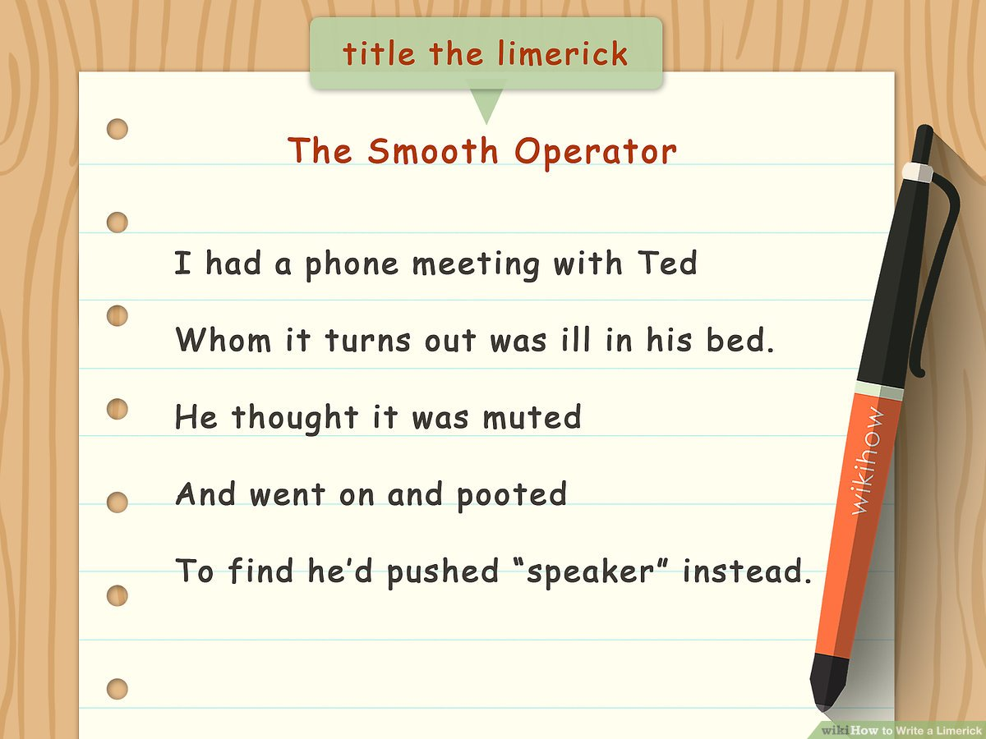
Please write two limericks of your own

