Cenerentola Cinderella


Italian Fairy Tale
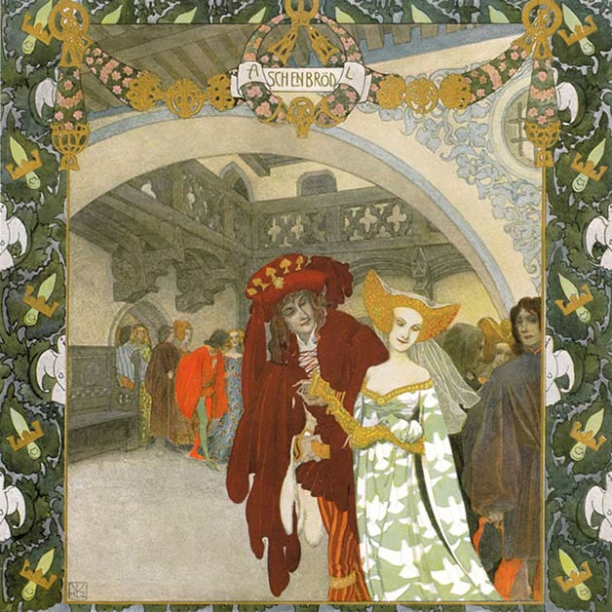
In the sea of malice envy frequently gets out of her depth; and, while she is expecting to see another drowned, she is either drowned herself, or is dashed against a rock, as happened to some envious girls, about whom I will tell you a story.
There once lived a Prince, who was a widower. He had an only daughter, so dear to him that he saw with no other eyes than hers; and he kept a governess for her, who taught her chain-work and knitting, and to make point-lace, and showed her such affection as no words can tell. But she was very lonely, and many a time she said to the governess, “Oh, that you had been my mother, you who show me such kindness and love,” and she said this so often that, at last, the governess, having a bee put into her bonnet, said to her one day, “If you will do as this foolish head of mine advises I shall be mother to you, and you will be as dear to me as the apple of my eye.”
Illustrated by Heinrich Lefler. Part of a fairy tale calendar published 1905 by Berger & Wirth, Leipzig.
She was going to say more, when Zezolla, for that was the name of the Princess, said, “Pardon me if I stop the word upon your tongue. I know you wish me well, therefore, hush—enough. Only show me the way. Do you write and I will subscribe.” “Well, then,” answered the governess, “open your ears and listen, and you will get bread as white as the flowers. You know well enough that your father would even coin false money to please you, so do you entreat him when he is caressing you to marry me and make me Princess. Then, bless your stars! you shall be the mistress of my life.”
When Zezolla heard this, every hour seemed to her a thousand years until she had done all that her governess had advised; and, as soon as the mourning for her mother’s death was ended, she began to feel her father’s pulse, and beg him to marry the governess. At first the Prince took it as a joke, but Zezolla went on shooting so long past the mark that at length she hit it, and he gave way to her entreaties. So he married the governess, and gave a great feast at the wedding.
Now, while the young folks were dancing, and Zezolla was standing at the window of her house, a dove came flying and perched upon a wall, and said to her, “Whenever you need anything send the request to the Dove of the Fairies in the Island of Sardinia, and you will instantly have what you wish.”
For five or six days the new stepmother overwhelmed Zezolla with caresses, seating her at the best place at table, giving her the choicest morsels to eat, and clothing her in the richest apparel. But ere long, forgetting entirely the good service she had received (woe to him who has a bad master!), she began to bring forward six daughters of her own, for she had never before told any one that she was a widow with a bunch of girls; and she praised them so much, and talked her husband over in such a fashion, that at last the stepdaughters had all his favour, and the thought of his own child went entirely from his heart. In short, it fared so ill with the poor girl, bad to-day and worse to-morrow, that she was at last brought down from the royal chamber to the kitchen, from the canopy of state to the hearth, from splendid apparel of silks and gold to dishclouts, from the sceptre to the spit. And not only was her condition changed, but even her name, for, instead of Zezolla, she was now called Cenerentola.
It happened that the Prince had occasion to go to Sardinia upon affairs of state, and, calling the six stepdaughters, he asked them, one by one, what they would like him to bring them on his return. Then one wished for splendid dresses, another to have head-ornaments, another rouge for the face, another toys and trinkets: one wished for this and one for that. At last the Prince said to his own daughter, as if in mockery, “And what would you have, child?” “Nothing, father,” she replied, “but that you commend me to the Dove of the Fairies, and bid her send me something; and if you forget my request, may you be unable to stir backwards or forwards; so remember what I tell you, for it will fare with you accordingly.”
Then the Prince went his way and did his business in Sardinia, and procured all the things that his stepdaughters had asked for; but poor Zezolla was quite out of his thoughts. And going on board a ship he set sail to return, but the ship could not get out of the harbour; there it stuck fast just as if held by a sea-lamprey. The captain of the ship, who was almost in despair and fairly tired out, laid himself down to sleep, and in his dream he saw a fairy, who said to him, “Know you the reason why you cannot work the ship out of port? It is because the Prince who is on board with you has broken his promise to his daughter, remembering every one except his own child.”
Then the captain awoke and told his dream to the Prince, who, in shame and confusion at the breach of his promise, went to the Grotto of the Fairies, and, commending his daughter to them, asked them to send her something. And behold, there stepped forth from the grotto a beautiful maiden, who told him that she thanked his daughter for her kind remembrances, and bade him tell her to be merry and of good heart out of love to her. And thereupon she gave him a date-tree, a hoe, and a little bucket all of gold, and a silken napkin, adding that the one was to hoe with and the other to water the plant.
The Prince, marvelling at this present, took leave of the fairy, and returned to his own country. And when he had given his stepdaughters all the things they had desired, he at last gave his own daughter the gift which the fairy had sent her. Then Zezolla, out of her wits with joy, took the date-tree and planted it in a pretty flower-pot, hoed the earth round it, watered it, and wiped its leaves morning and evening with the silken napkin. In a few days it had grown as tall as a woman, and out of it came a fairy, who said to Zezolla, “What do you wish for?” And Zezolla replied that she wished sometimes to leave the house without her sisters’ knowledge. The fairy answered, “Whenever you desire this, come to the flower-pot and say:
My little Date-tree, my golden tree,
With a golden hoe I have hoed thee,
With a golden can I have watered thee,
With a silken cloth I have wiped thee dry,
Now strip thee and dress me speedily.
And when you wish to undress, change the last words and say, ‘Strip me and dress thee.'”
When the time for the feast was come, and the stepmother’s daughters appeared, dressed out so fine, all ribbons and flowers, and slippers and shoes, sweet smells and bells, and roses and posies, Zezolla ran quickly to the flower-pot, and no sooner had she repeated the words, as the fairy had told her, than she saw herself arrayed like a queen, seated upon a palfrey, and attended by twelve smart pages, all in their best clothes. Then she went to the ball, and made the sisters envious of this unknown beauty.
Even the young King himself was there, and as soon as he saw her he stood magic-bound with amazement, and ordered a trusty servant to find out who was that beautiful maiden, and where she lived. So the servant followed in her footsteps; but when Zezolla noticed the trick she threw on the ground a handful of crown-pieces which she had made the date-tree give her for this purpose. Then the servant lighted his lantern, and was so busy picking up all the crown-pieces that he forgot to follow the palfrey; and Zezolla came home quite safely, and had changed her clothes, as the fairy told her, before the wicked sisters arrived, and, to vex her and make her envious, told her of all the fine things they had seen. But the King was very angry with the servant, and warned him not to miss finding out next time who this beautiful maiden was, and where she dwelt.
Soon there was another feast, and again the sisters all went to it, leaving poor Zezolla at home on the kitchen hearth. Then she ran quickly to the date-tree, and repeated the spell, and instantly there appeared a number of damsels, one with a looking-glass, another with a bottle of rose-water, another with the curling-irons, another with combs, another with pins, another with dresses, and another with capes and collars. And they decked her out as glorious as the sun, and put her in a coach drawn by six white horses, and attended by footmen and pages in livery. And no sooner did she appear in the ball-room than the hearts of the sisters were filled with amazement, and the King was overcome with love.
When Zezolla went home the servant followed her again, but so that she should not be caught she threw down a handful of pearls and jewels, and the good fellow, seeing that they were not things to lose, stayed to pick them up. So she had time to slip away and take off her fine dress as before.
Meanwhile the servant had returned slowly to the King, who cried out when he saw him, “By the souls of my ancestors, if you do not find out who she is you shall have such a thrashing as was never before heard of, and as many kicks as you have hairs in your beard!”
When the next feast was held, and the sisters were safely out of the house, Zezolla went to the date-tree, and once again repeated the spell. In an instant she found herself splendidly arrayed and seated in a coach of gold, with ever so many servants around her, so that she looked just like a queen. Again the sisters were beside themselves with envy; but this time, when she left the ball-room, the King’s servant kept close to the coach. Zezolla, seeing that the man was ever running by her side, cried, “Coachman, drive on quickly,” and in a trice the coach set off at such a rattling pace that she lost one of her slippers, the prettiest thing that ever was seen. The servant being unable to catch the coach, which flew like a bird, picked up the slipper, and carrying it to the King told him all that happened. Whereupon the King, taking it in his hand, said, “If the basement, indeed, is so beautiful, what must the building be. You who until now were the prison of a white foot are now the fetter of an unhappy heart!”
Then he made a proclamation that all the women in the country should come to a banquet, for which the most splendid provision was made of pies and pastries, and stews and ragouts, macaroni and sweetmeats—enough to feed a whole army. And when all the women were assembled, noble and ignoble, rich and poor, beautiful and ugly, the King tried the slipper on each one of the guests to see whom it should fit to a hair, and thus be able to discover by the help of the slipper the maiden of whom he was in search, but not one foot could he find to fit it. So he examined them closely whether indeed every one was there; and the Prince confessed that he had left one daughter behind, “but,” said he, “she is always on the hearth, and is such a graceless simpleton that she is unworthy to sit and eat at your table.” But the King said, “Let her be the very first on the list, for so I will.”
So all the guests departed—the very next day they assembled again, and with the wicked sisters came Zezolla. When the King saw her he had his suspicions, but said nothing. And after the feast came the trial of the slipper, which, as soon as ever it approached Zezolla’s foot, it darted on to it of its own accord like iron flies to the magnet. Seeing this, the King ran to her and took her in his arms, and seating her under the royal canopy, he set the crown upon her head, whereupon all made their obeisance and homage to her as their queen.
When the wicked sisters saw this they were full of venom and rage, and, not having patience to look upon the object of their hatred, they slipped quietly away on tip-toe and went home to their mother, confessing, in spite of themselves, that—
“He is a madman who resists the Stars.”

